|  |  |  |
| --- | --- | --- |
|  |  | **Implementation of a Manufacturing Execution System for a Learning Factory**  **Mattis Tom Ritter**1**, Cheng Yee Low**2,*  1Faculty of Mechanics and Electronics,  Heilbronn University of Applied Sciences, Max-Planck-Str. 39, 74081 Heilbronn, Baden-Württemberg, GERMANY  2Faculty of Mechanical and Manufacturing Engineering, Universiti Tun Hussein Onn Malaysia,86400 Parit Raja, Johor, MALAYSIA  *Corresponding Author Designation  DOI: https://doi.org/10.30880/rpmme.00.00.0000.00.0000  Received 00 Month 2023; Accepted 01 Month 2023; Available online 02 Month 2023  **Abstract:** In times of the fourth industrial revolution data is the most valuable resource of a company, but many small and medium-sized companies struggle to get the most out of it. The objective of this paper is transferring knowledge on how to implement a Manufacturing Execution System by using a Learning Factory as demonstrator and creating a guideline to follow along. In order to do so a detailed explanation of the connection from automation level of the Fischertechnik Learning Factory to the Manufacturing Execution System arc.ops from Arcstone is provided. To showcase the functionalities a dashboard is created that displays the current state of each workstation. This is a major step towards an industry 4.0 ready factory as further steps can easily be built on the existing foundation and the benefits of unlocking the value of data are shown.  **Keywords:** Manufacturing Execution System, Learning Factory, Arcstone |

1. **Introduction**

The fourth industrial revolution, driven by digitalization, robotics, and artificial intelligence, is changing industrial production fundamentally. Mercedes-Benz [1] is integrating these pillars into its production processes to reduce costs and improve efficiency. The goal of Industry 4.0 is to connect workers and machines through digitalization, allowing for the collection and analysis of production data. Advancing robot technology helps to automate and support production steps. The project aims to create a factory simulation that is operated entirely by robots and implement a Manufacturing Execution System (MES) to collect and analyse sensor data. Additionally, Mercedes-Benz emphasizes the importance of providing information to customers and the MES can be used to share production information with them.

Smaller and medium-sized enterprises (SMEs) often lack the necessary digitization and connectivity to efficiently collect and distribute data and their workforce is not trained in this field. This paper shows the importance of a MES and how a factory simulation can demonstrate the benefits of a connected factory. The use of training material can help address these challenges and show managers as well as workers that adopting industry 4.0 is achievable for everyone.

The state of Baden-Württemberg [2] points out that keeping pace with digitalization and ever-shorter innovation cycles is a major challenge for companies. Therefore, ongoing networking, knowledge and technology transfer, as well as constant competence development, are becoming increasingly important to remain competitive, especially for SMEs with limited resources. As the objective is transferring knowledge, a look into the capabilities of a MES is taken firstly.

As Kletti [3] states a MES is designed to improve operational efficiency and increase overall productivity by giving manufacturers insight into their production processes and providing them with tools to help optimize workflows. This is achieved by monitoring all aspects of the production process in real time and combining the functional scopes of production, personnel management and quality assurance. The VDI (Verein Deutsche Ingenieure, engl. Association of German Engineers) developed the guideline VDI 5600 [4], which describes the tasks of a MES are the following:

• Detailed planning and detailed scheduling control

• Operating resources management

• Material management

• Personnel management

• Data acquisition and processing

• Interface management

• Performance analysis

• Quality management

• Information management

• Order management

• Energy management

To cover most of the features when implementing the MES a dashboard will be created and all the steps to accomplish this will be put together as a platform for knowledge transfer.

1. **Materials and Methods**

A guide on how to do the implementation is created to function as a knowledge transfer platform for SMEs. For the demonstrator Arcstone is used as the MES software and is implemented on the Fischertechnik Learning Factory in the Innovationslab of the UTHM.

2.1 Arcstone’s MES

Arcstone enables all enterprises to unlock the value of data [5] by making it visible and traceable. To do so they provide the MES arc.ops that comes with 20 modules. It features a specific tool for connecting to machines and pull the data named arc.quire, which works with industry’s standard protocols, including OPCUA and is also capable of manual data input. As a hardware integrator it writes the data into a SQL database inside the MES, from where arc.flow can distribute the data further to the enterprise resource planning (ERP) or other top level planning systems. Figure 1 shows Arcstone’s MES solutions embedded in the ISA 95 framework [6].

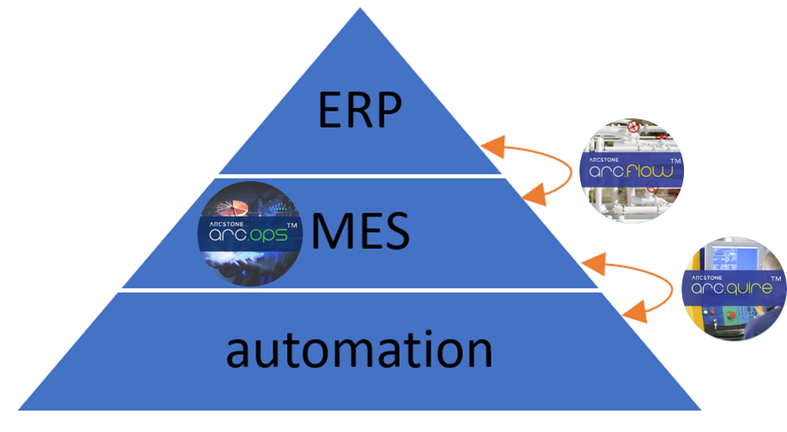

**Figure 1: Arcstone’s MES in the ISA 95 framework**

2.2 Fischertechnik Learning Factory

The Fischertechnik Learning Factory [7] is used in the project as depicted in figure 2. It is a learning factory that comes with many features and in the following a typical process is described. The transport arm fetches the workpiece from the high-bay warehouse and places it on the output station. From there the vacuum gripper moves it to the multiprocessing station with oven. After the milling machine the workpiece gets transported to the sorting line with colour detection where it is pushed from the conveyor belt into the corresponding chute. It can be seen that the simulation is already completely operated by robots and also fully sensorized.

The Learning Factory is connected to a PLC from Beckhoff and controlled with their software TwinCAT 3. This means that all input and output-data is available inside the system.

**Figure 2: Fischertechnik Learning Factory**

1. **Results and Discussion**

The connection from the Fischertechnik Learning Factory to Arcstone’s MES is described in detail and the creation of a dashboard as one of the functionalities of the MES is shown.

3.1 Dataflow from Automation Level to MES

Figure 3 illustrates the dataflow from the automation software TwinCAT to the MES arc.ops and where the data is stored during this process. Data is written from the PLC into a OPCUA server, from where arc.quire pulls the data to a SQL server inside the MES. Arc.ops accesses the data from this database for further processing and visualization.



**Figure 3: Dataflow**

The architecture of the connection between the automation software TwinCAT 3 and the OPCUA server is shown in figure 4. The left PC is the engineering computer, where the PLC program for the Learning Factory is developed and the right PC is an industrial computer from Beckhoff. Here TwinCAT also has to be installed, but functions only as a runtime for the PLC. Furthermore, the OPCUA server is hosted on the industrial PC. The access to the server data happens from the engineering computer with the OPCUA expert, which is used to verify the successful creation of the server. In this architecture it is important that a valid license for the function TF6100 [8] is activated in each TwinCAT software product.

**Figure 4: Architecture of connection from PLC to server**

In order to pull data from the OPCUA server to the MES database an arc.quire profile needs to be set up. Figure 5 shows the general settings at the top as well as the source and destination setup at the bottom. Insert a meaningful name as well as a short description and the correct data provider and export type. Set the server URL to the URL of the OPCUA server, choose a publish interval and enter the authentication credentials if the OPCUA server requires them. Afterwards, add the wanted data below, by inserting the same Node ID as in the OPCUA server. Fill in the right connection string for the destination, by using the username and password from Arcstone and change the names of database, table and different columns if wanted. When the profile is running the selected data gets written into a SQL database, where the arc.ops software has access. It is located inside the UTHM server as defined in the destination setup and can be viewed by using Microsoft SQL Server Management.



**Figure 5: Connection setup of the arc.quire profile**

Now that the connection to the MES is established, the next step is to make use of it. Arcstone offers a module where dashboards can be created that give an overview of the state of the workstations or prepare sensor values for the observer.

To do so add a new data source inside arc.ops by using the same connection string as in the arc.quire profile to access the previous created database. This is shown on the left side of figure 6. Navigate to data sources, which opens the dashboard data source wizard and type in a SQL query to get the required data from the SQL database. To simplify this process the query builder can be utilized. When it is needed to separate the data of every sensor a query for each has to be written. The example on the right side of figure 6 shows a query that selects only the newest value of S1_I1, by filtering for the TAG_NAME which is the combination of the display name and node ID. The data is now ready to be displayed in the dashboard by binding it to an object. For this the most common way is a grid, but there are also bar graphs etc. possible.

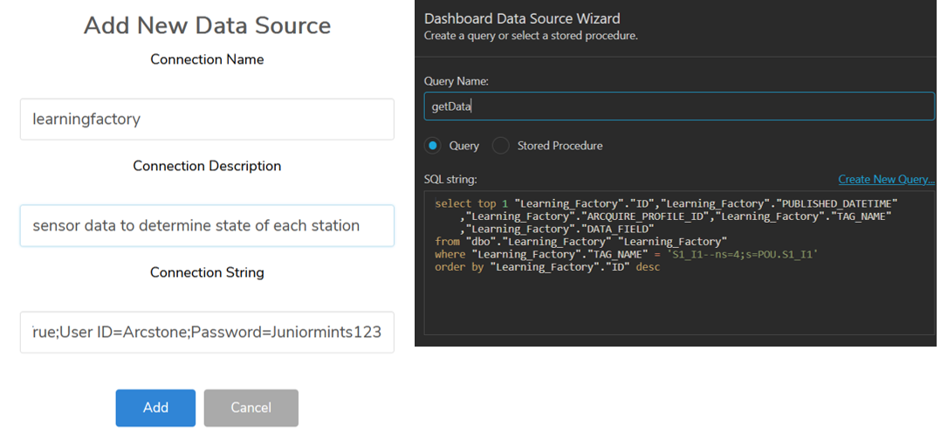

**Figure 6: Add new data source (left) and dashboard data source wizard (right)**

3.2 Creating a Dashboard

For each station of the Fischertechnik Learning Factory a sensor is chosen that determines if a station is running or inactive, respectively if a chute is full or empty. Table 1 gives a summary of the sensors and the meaning of their value for each station and chute.

**Table 1: State of each station and chutes**

|  |  |  |  |
| --- | --- | --- | --- |
| Station | Sensor | State | Sensor value |
| High-bay warehouse | S1_I1 | Running | false |
| Inactive | true |
| Vacuum gripper robot | S2_I2 | Running | false |
| Inactive | true |
| Oven | S3_I6 | Running | true |
| Inactive | false |
| Milling machine | S3_I1 | Running | false |
| Inactive | true |
| White chute | S4_I4 | Full | false |
| Empty | true |
| Red chute | S4_I5 | Full | false |
| Empty | true |
| Blue chute | S4_I6 | Full | false |
| Empty | true |

As not all sensor values represent the same state the data from DATA_FIELD can not be displayed directly in a grid, but needs to be processed to find the correct state. This can be done by adding a calculated field as shown in figure 7, where the state is selected with an if-query.

**Figure 7: Assign data to grid**

For the high-bay warehouse the query is shown in equation 1, where the first input is the statement that is checked, the second input is the return if the statement is true and the third input is returned if it is false.

Iif([DATA_FIELD] = ‘True’, ‘Inactive’, ‘Running’) *Eq.1*

To finsih the dashboard the process is repeatd for every station and chute. An image of each station is added below the corresponding grids. Figure 8 shows the final dashboard, where the workpiece is currently in the oven and only the white chute is full.

**Figure 8: Dashboard**

1. **Conclusion**

The MES has been successfully connected to the learning factory and a dashboard that visualizes the current state of the stations has been created. However, there are still additional functionalities and capabilities of the MES that can be implemented. The guideline VDI 5600 has been partially met, but there is still more possible. Features of the MES, such as order tracking, job scheduling, workflow creation, and personnel management, are not yet implemented. In addition, there are improvements that can be made to the dashboard, such as showing more sensor data and providing more detailed information on the production process. The step after this would be to connect the MES to an ERP.

Overall, the focus of this project was to demonstrate the implementation of a MES into a factory, which was fully achieved and it is now up to others to take it to the next level.

**Acknowledgement**

I would like to express my appreciation for the unwavering support and guidance provided by Dr. Low Cheng Yee. Furthermore, I would like to extend my gratitude to all the individuals working at the UTHM-Frauenhofer IEM Innovation Lab. Collaborating with such helpful and dedicated people has been an absolute pleasure. The experience of being part of the project learning factory has been truly enriching, and I would like to give special thanks to Moritz Höhnel for his exceptional contributions.

**References**

[1] Mercedes Benz Group (2023). *Industry 4.0 and the networked factory*. Retrieved on May 20, 2023, from https://group.mercedes-benz.com

[2] Ministry for Economy, Labour and Tourism (2023). *Technology and Knowledge Transfer*. Retrieved on June 30, 2023, from https://www.wirtschaft-digital-bw.de

[3] Kletti, J.. *MES – Manufacturing Execution System*. 2nd Ed. Mosbach. Springer Vieweg. 2015

[4] Verein Deutscher Ingenieure. *Manufacturing execution systems (MES)*.Düsseldorf. VDI 5600. 2016

[5] Arcstone (2022). *Unlocking the Value of Data*. Retrieved on April 30, 2023, from https://www.arcstone.co

[6] International Society of Automation. *Enterprise-Control System Integration*. Research Triangle Park. ISA95. 2014

[7] Fischertechnik (2023). *Lernfabrik 4.0*. Retrieved on May 5, 2023, from https://www.fischertechnik.de

[8] Beckhoff (2023). *TF6100 | TwinCAT 3 OPC UA*. Retrieved on May 20, 2023, from https://infosys.beckhoff.com